|  |
| --- |
| Day 10 assignments by Lokesh nadella |

1.write the two points discussed about inheritance class?

Inheritance is the process of reusing the base class methods in the derived class

Main goal of inheritance is reusability and to remove duplicate code

2.write example code for :

1.single inheritance

2.multi level inheritance

using System;

using System.Collections.Generic;

using System.Linq;

using System.Text;

using System.Threading.Tasks;

namespace day_10_morning_single

{

class Algebra

{

public int add(int a, int b)

{

return a + b;

}

public int sub(int a, int b)

{

return a - b;

}

}

class TotalMaths : Algebra

{

public int mul(int a, int b)

{

return (a * b);

}

}

internal class Program

{

static void Main(string[] args)

{

TotalMaths tm = new TotalMaths();

Console.WriteLine(tm.add(145, 5));

Console.WriteLine(tm.sub(23, 5));

Console.WriteLine(tm.mul(67, 5));

Console.ReadLine();

}

}

}



2. multi level:::

using System;

using System.Collections.Generic;

using System.Linq;

using System.Text;

using System.Threading.Tasks;

namespace day_10_morning_multi

{

class Algebra

{

public int add(int a, int b)

{

return a + b;

}

public int sub(int a, int b)

{

return a - b;

}

}

class TotalMaths : Algebra

{

public int mul(int a, int b)

{

return (a * b);

}

}

class Allsubjects : TotalMaths

{

public string methane()

{

return "CH4";

}

}

internal class Program

{

static void Main(string[] args)

{

Allsubjects obj = new Allsubjects();

Console.WriteLine(obj.add(654, 98));

Console.WriteLine(obj.sub(6543, 587));

Console.WriteLine(obj.mul(513, 300));

Console.WriteLine(obj.methane());

Console.ReadLine();

;

}

}

}

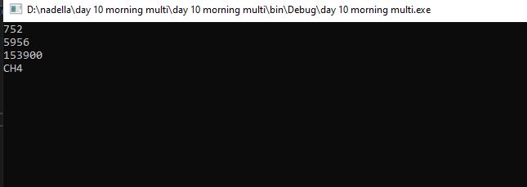

3.write a c# for method overloading??

using System;

using System.Collections.Generic;

using System.Linq;

using System.Text;

using System.Threading.Tasks;

namespace day10_morning_overloadig

{

class Algebra

{

public int add(int a, int b)

{

return a + b;

}

public int add(int a, int b, int c)

{

return a + b + c;

}

public int add(int a, int b, int c, int d)

{

return a + b + c + d;

}

}

internal class Program

{

static void Main(string[] args)

{

Algebra obj = new Algebra();

Console.WriteLine(obj.add(87, 56));

Console.WriteLine(obj.add(877, 67, 7));

Console.WriteLine(obj.add(567, 645, 867, 9));

Console.ReadLine();

}

}

}

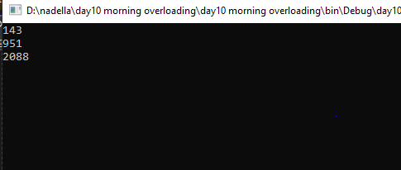

4.write a c# for method over riding using new key word???

using System.Collections.Generic;

using System.Linq;

using System.Text;

using System.Threading.Tasks;

namespace day_10_morning_over_riding

{

class EnglishMessage

{

public void PrintHi()

{

Console.WriteLine("HI");

}

public void PrintHello()

{

Console.WriteLine("Hello");

}

public void PrintGM()

{

Console.WriteLine("Good Morning");

}

}

class TeluguMessage : EnglishMessage

{

public new void PrintGM()

{

Console.WriteLine("Subodhayam");

}

}

internal class Program

{

static void Main(string[] args)

{

TeluguMessage msg = new TeluguMessage();

msg.PrintHi();

msg.PrintHello();

msg.PrintGM();

Console.ReadLine();

}

}

}

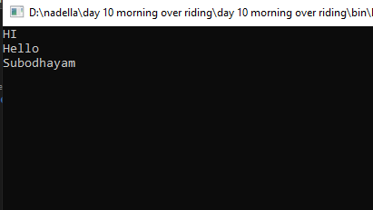

5.write a c# program for method over riding using virtual and over ride keyword??

using System;

using System.Collections.Generic;

using System.Linq;

using System.Text;

using System.Threading.Tasks;

namespace day_10_morning_over_riding_and_virtual

{

class EnglishMessage

{

virtual public void PrintHi()

{

Console.WriteLine("Hi");

}

virtual public void PrintHello()

{

Console.WriteLine("Hello");

}

virtual public void PrintGM()

{

Console.WriteLine("Good Morning");

}

}

class TeluguMessage : EnglishMessage

{

override public void PrintGM()

{

Console.WriteLine("Subodhayam");

}

}

internal class Program

{

static void Main(string[] args)

{

TeluguMessage msg = new TeluguMessage();

msg.PrintHi();

msg.PrintHello();

msg.PrintGM();

Console.ReadLine();

}

}

}

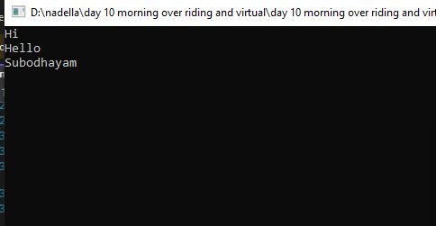

6.pictorial representation of 3 types of inheritance??

Multiple level:::

Multilevel inheritance::

7.what is polymorphism??

Ability of an object to take many forms.there are two types.they are::

Method overloading

Method overriding